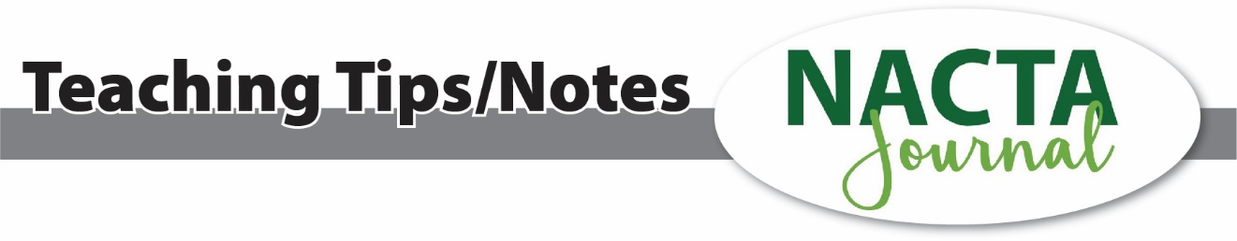
Developing Critical Communication Skills through Authentic Collaborations

Introduction
Effective communication is a critical skill for students, particularly in fields requiring the synthesis and presentation of complex information. To develop oral and written communication skills in the International Agriculture and Development (INTAD) graduate program capstone class, our students have the opportunity to work alongside professionals in the field through a collaboration with Catholic Relief Services (CRS). Through this collaboration, our students have a unique opportunity to act as consultants with an important and authentic task: reviewing CRS projects and grant opportunities related to a specific area of work and creating a practical, concise report for professional use.

Procedure
To implement a similar idea in your class and develop students' critical communication skills through authentic collaborations, we suggest following these steps:
Establish Collaboration with a Real-World Partner Identify and establish a partnership with an organization that can provide meaningful, real-world projects for students. For the INTAD capstone class, collaboration was formed with CRS’s Asia unit, allowing students to communicate with professionals working in the region. We have found that when students know that their efforts will directly impact real organizations and people, they take the task very seriously.

Define the Project Scope and Objectives For each class, clearly define the project scope. For our class, CRS developed a scope of work that they would typically give to a consultant, and our students had to interpret the scope of work to the best of their ability. The ultimate objective was to produce concise reports that CRS could use for reporting purposes and future proposal development. When students had questions about what was required for the project, they needed to ask the CRS staff for clarification, rather than the instructors.

Emphasize Stakeholder Needs A central objective of authentic collaboration is to allow students to practice effective listening and responding to stakeholder needs. In our case, CRS needed concise, actionable reports. Feedback from CRS highlighted the importance of brevity and clarity while also valuing the research-based findings the students included for context. The 80-page first draft initially generated by students was deemed too lengthy by the collaborators, leading students to refine their approach to distill the information into a 10-page report. This was counterintuitive to many students, who were used to being rewarded for being praised for producing lengthy and exhaustively researched documents.

Incorporate Iterative Feedback Incorporate a system of iterative feedback throughout the semester where students can refine their work based on stakeholder input. In our case, it was cumbersome to arrange for our collaborators to Zoom into class due to time constraints and the differing time zones. Still, we found it critical to open feedback channels for our students so they could practice responding to collaborator reactions as the project progressed.

Assessment

Because we emphasize critical listening skills, we focus our assessment on students' responsiveness to collaborator feedback. We assess students in the following four categories:
- Stakeholder feedback: Collect detailed feedback from the collaborators to evaluate how well students addressed the organization's needs and incorporated feedback into their reports.
- Student reflections: Have students reflect on how they received and applied feedback from the collaborators, noting specific changes they made to improve their reports.
- Iterative improvement: Assess the progression of students' work over multiple drafts, highlighting their ability to adapt and refine their reports based on collaborator input.
- Final product quality: Evaluate the final reports for conciseness, clarity, and practicality, with a focus on how well they align with the collaborator’s feedback and requirements.

Conclusion
The collaboration with Catholic Relief Services in the International Agriculture and Development capstone class demonstrates the value of authentic projects in developing students' communication skills. By focusing on stakeholder needs and responding to feedback, students gained practical experience in critical communication skills. This project-based learning approach not only prepares students for the communication skills vital for their future careers but also contributes valuable resources to our collaborators.

Submitted by:

Melanie Miller Foster, melanie@psu.edu, The Pennsylvania State University
Paul Esker, pde6@psu.edu, The Pennsylvania State University

